

**Aqaba University of Technology**

**Faculty of Information Technology**

**Department of Software Engineering**

**For AUT**

**By**

**Baha'a Al-Deen Al-Naboulsi**

**201720200**

**Supervisor**

**Dr. ----**

**A graduation Project Submitted in Partial Fulfillment of**

**the Requirements for the BSc in Software Engineering**

**June 2021**

**TABLE OF CONTENTS**

**Particulars Page Nos.**

1. Introduction………………………………….……8
   1. Project Overview…………………………….9
   2. Project Description…………………………...9

**AIRLINE RESERVATION SYSTEM**

**ABSTRACT**

In an era in which the production of knowledge is accelerating, the Internet is the main means of sharing information and facts, and with the continuous development, the Internet has more uses such as providing services and social media and freelance work and study remotely. It is responsible for providing and arranging information or services in a controlled sequence, for safety, and for giving validity.

**INTRODUCTION**

* 1. **Project Overview**

Airline reservation system contains the details about flight schedule and its fare tariffs, passenger reservations and ticket records.

* 1. **Project Description**

Airline reservation system it saves time as it allows online procedure as user no longer to wait in a queue to book the flights. its automatically generated by the server. admin is the main authority who can do addition, deletion and modification of flights if required.

The application for the storage of the data has built using the database MySQL and all the user interface have been designed using html and CSS language.

The airline reservation project is an implementation of a general airline ticketing website, which help the customer to search the availability and prices of various airline tickets.

The project also covers various features like online registration of the users, by adding, deleting and modifying the customer details, flights information.

* 1. **Definitions, Acronyms, Abbreviations**

**WWW:** World wide web

**MySQL:** RDBMS based on SQL which is used for adding, removing and modifying information in the database

**RDBMS:** Relational Database Management System

**HTML:** Hyper Text Markup Language

**CSS:** Cascading Style Sheet

**PHP:** Hypertext Preprocessor

**HTTP:** Hypertext Transfer Protocol

**Problem Definition**

* 1. **Existing System**

In few countries if a person wants to book a flight ticket, he uses to follow one of these things:

**Disadvantages:**

* He needs to allocate money and time to go to the airport to book a ticket.
* Dealing with paper documents that require careful preservation and effort in managing them.
* Cannot upload & download the latest updates.
* Not use of web services and remoting.
* Less security.
  1. **Proposed System**

Our proposed system allows to book the tickets, view timings and cancel their tickets online and provide for passengers as a print document.

This proposed system will solve the previously mentioned problems.

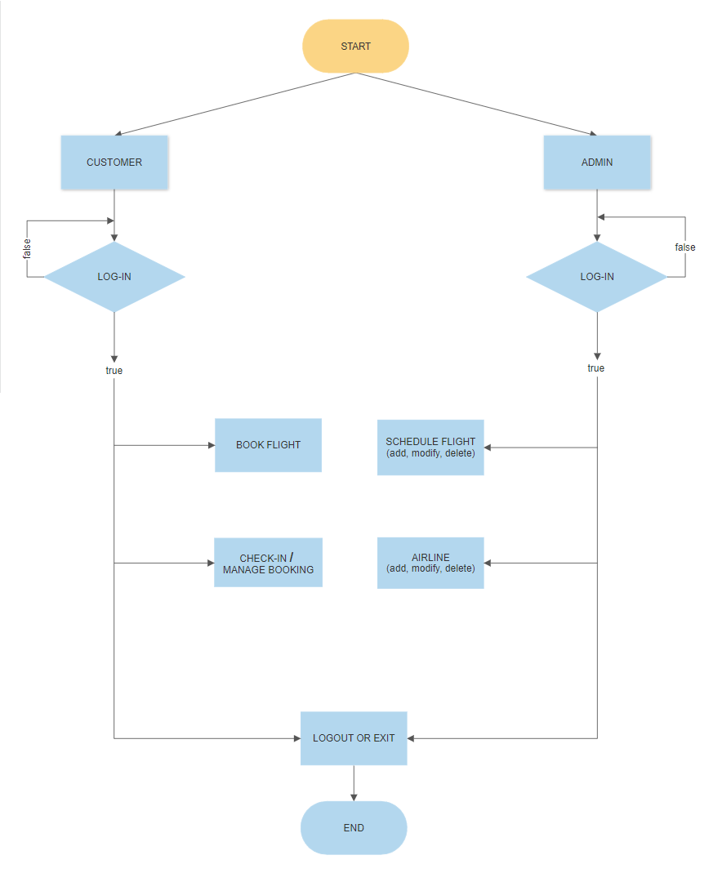

**Feasibility Study**

Preliminary investigation examines project feasibility. The likelihood the system will be useful to the organization. The main objective of the feasibility study is to test the Technical Operational and Economical feasibility for adding new modules and debugging old running system. There are aspects in the feasibility study portion of the preliminary investigation:

* Technical Feasibility.
* Operation Feasibility.
* Economic Feasibility.

1. **Technical Feasibility**

The technical issue usually raised during the feasibility stage of the investigation includes the following:

* Does the necessary technology exist to do what is suggested?
* Does the proposed equipment have the technical capacity to hold the data required to use the new system?
* Will the proposed system provide adequate response to inquiries, regardless of the number or location of users?
* Can the system be upgraded if developed?
* Are there technical guarantees of accuracy, reliability, ease of access and data security?

Earlier no system existed to cater to the needs of Secure Infrastructure Implementation System. The current system developed is technical feasibility.

1. **Operation Feasibility**

Proposed project is beneficial only if they can be turned out into information system that will meet the organization's operating requirement. Some of the important issues raised are to test the operational feasibility of the project includes the following:

* Is there sufficient support for the management from the users?
* Will the system be used and work properly is it is being developed and implemented?
* Will there be any resistance from the user that will undermine the possible application benefits?

1. **Economic Feasibility**

A system can be developed technically and that will be used if installed must still be a good investment for the organization. In the economic feasibility, the development cost in the creating system is evaluated against the ultimate benefit derived from the new systems. Financial benefit must equal or exceed the costs.

***

***

***

**System Analysis**

System analysis is a detailed study of the various operations performed by a system and their relationships within and outside of the system. here the key question is what all problem exists in the present system? what must be done to solve the problem?

1. **Software Requirement Specification (SRS)**

This section provides software requirements to a level of detail sufficient to enable designers to design the system a tester to test the system.

This section contains all of the functional and quality requirements of the system. It gives a detailed description of the system and all its features.

**Introduction**

**Purpose:** the main purpose of preparing this document is to give a general insight into the analysis and requirements of the existing system.

**Scope:** this document plays a vital role in the development life cycle (SDLC) and it describes the complete requirement of the system. it’s meant for use by developers and will be the basic during testing phase. any changes made to the requirements in the future will have to go through formal change approval process.

1. **functional requirement**

* the required functions of the system, which are according to roles:
* **log in** to end users
* **Passenger role:**

In the registration form, the traveler must enter his personal information and contact methods and reservation check.

* **Administration role:**

The system administrator must be able to add, update and modify flights and view the customer details.

* the required data of the system is:
* **flight:** Airline name, flight number, class, destination, from, price, time & date departure, time arrival.
* **ticket record:** id-ticket, seat number, gate.
* **passenger:** passenger name, phone number, email.

1. **Non-Functional Requirements**

**1.Reliability:**

System shall give accurate and precise results; also, the number of errors should be low.

**2.Availability:**

System shall be available every time the need it, also the probability of unavailability and mean time to failure should below.

**3.Performance:**

The response time when retrieve data shall not be more than 30 seconds.

**4.Ease of use:**

System shall have a simple and usable interface that are easy to use and do not need long time to train on it.

**5.Security:**

System shall be secure from any unauthorized access and the accessibility.

**4.3.1. Performance Requirement**

This subsection specifies numerical requirements placed on the software or on the human interaction with the software, as a whole...will include:

* 300 Terminals will be supported at a time
* Only text information will be supported (HTTP)

**4.3.2. Dependencies Requirement**

Use password authentication and role-based security mechanisms to prevent unauthorized access.

We make a backup copy of the database in case the primary database fails.

1. **Software requirement**

* WINDOWS OS (Windows 7, 8, 10) Or Linux
* VS code {HTML, CSS}
* PHP Wamp Server for Windows (Apache)
* Database MySQL For Backend.

**Server side** An Apache Web server will accept all requests from the client. A development database will be hosted locally (using MySQL; the production database is hosted centrally.

1. **Hardware requirement**

* Intel I3 2.8 GHz processor and above
* RAM 2_GB and above
* HDD 20_GB Hard Disk space and above
  1. **User Characteristics**

**Customer**

All specific knowledge or skills are required from the feeder.

* Educational level: users should be comfortable with the English language.
* Experience: user should have prior information regarding the online booking.

**Administrator**

The Administrator must be able to manage user rights, so he must be careful while dealing with data.

* 1. **Constraints**

The information of all users, subjects and allocations must be stored in a database that is accessible be every connected system. MySQL used for database.

* users may access from any system connected to the online database.
* users must have their correct username and password to enter into their account.
* Only authorized person can access related details.

**System Design**

Systems design is the process of defining the architecture, components, modules, interfaces, and data for a system to satisfy specified requirements.

1. **Use Case Diagram**

Use Case Diagram is a type of behavioral diagram the main purpose of a use case diagram is to show what system functions are performed for which actor.

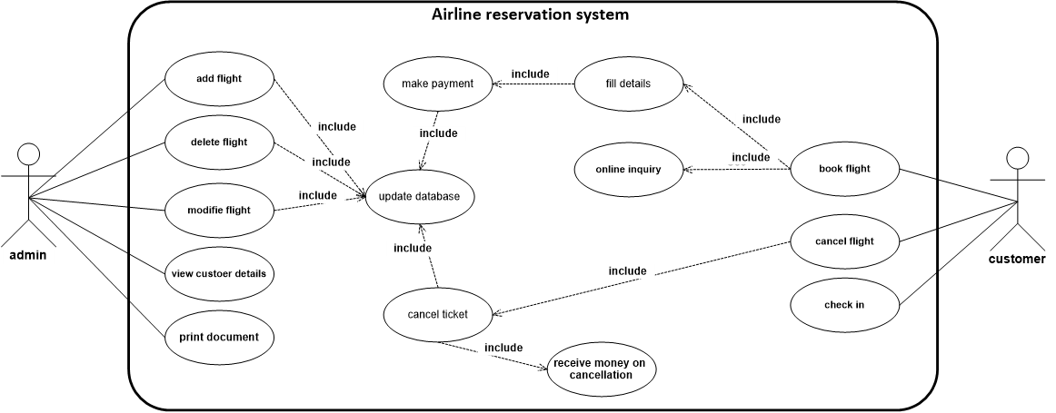

Figure 3.1: Use-Case Diagram

1. **Sequence Diagram**

Sequence diagram is a type of behavioral diagram and the main purpose of a sequence diagram is to show the chronological order sequence of messages exchanged between processes.

1. **Connect to the Internet:**

**Sequence name:** Login.

**Actors:** End-user (Admin or Customer).

**Description:** The End-user login to the system.

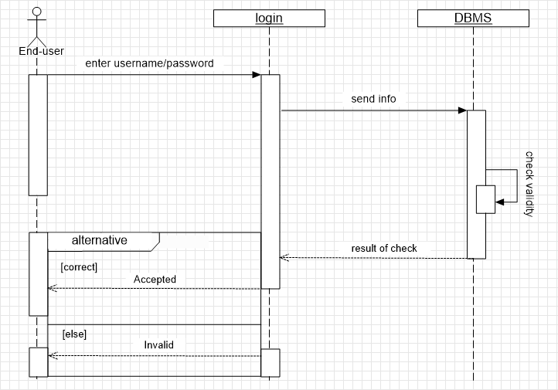

Figure 3.2: Sequence Diagram

* 1. **Add flights:**

**Sequence name:** Add.

**Actors:** Admin.

**Description:** The Admin add flights to the system.

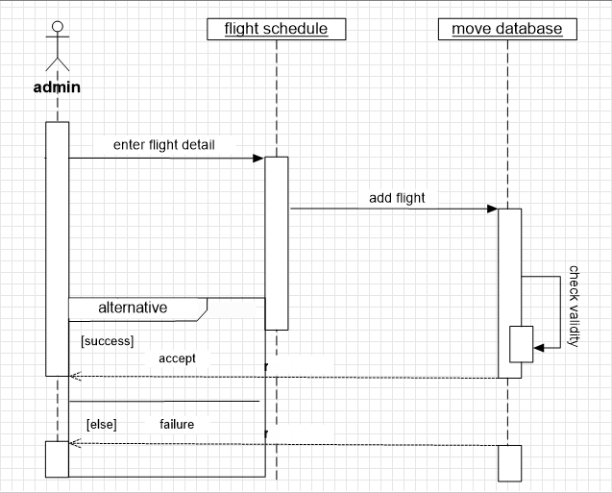

Figure 3.3: Sequence Diagram

* 1. **Modify Flight:**

**Sequence name:** Modify.

**Actors:** Admin.

**Description:** The Admin Modifyflights in the system.

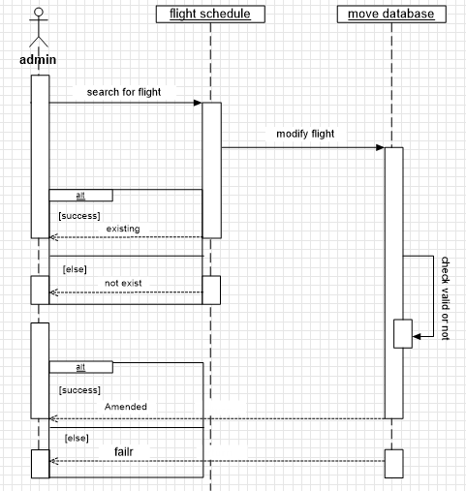

Figure 3.4: Sequence Diagram

* 1. **Delete Flight:**

**Sequence name:** Delete.

**Actors:** Admin.

**Description:** The Admin Delete flights from the system.

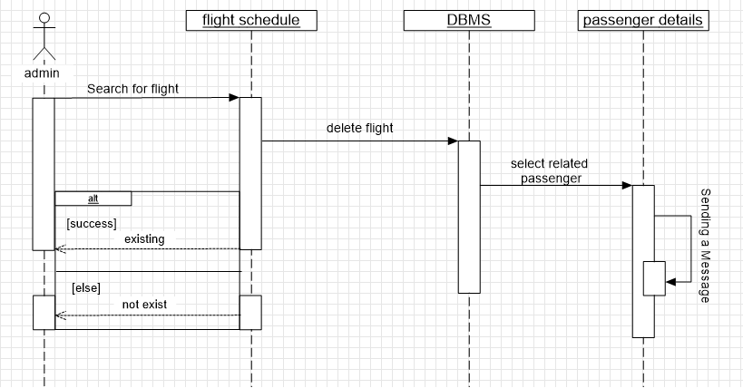

Figure 3.5: Sequence Diagram

* 1. **Ticket Booking:**

**Sequence name:** Book.

**Actors:** Customer.

**Description:** The Customer Book the Ticket.

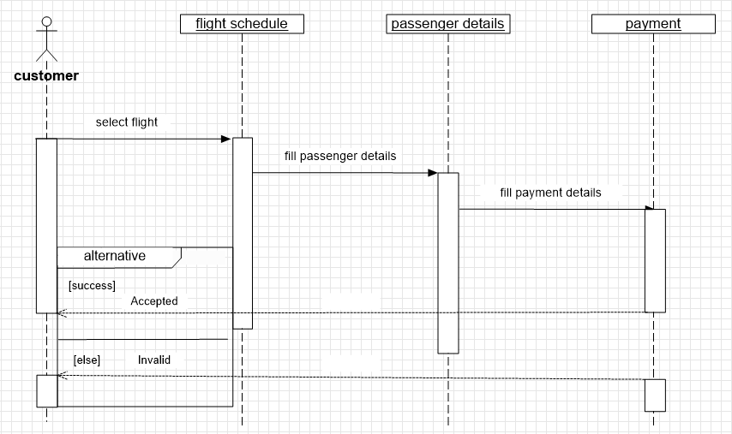

Figure 3.5: Sequence Diagram

* 1. **Cancel Ticket:**

**Sequence name:** Cancel.

**Actors:** Customer.

**Description:** The Customer Cancel the Ticket.

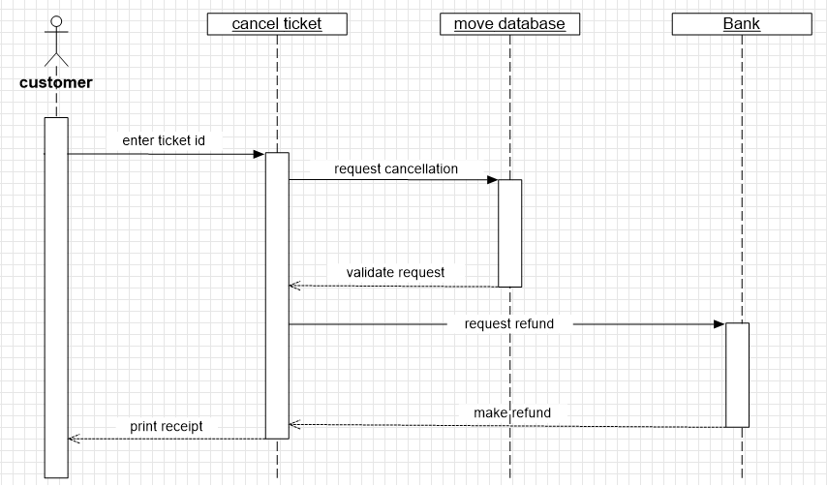

Figure 3.6: Sequence Diagram

* 1. **Check-In:**

**Sequence name:** Check-in.

**Actors:** Customer.

**Description:** The Customer Check-in the Ticket.

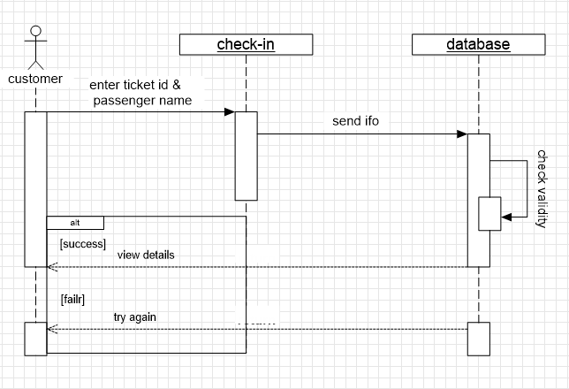

Figure 3.7: Sequence Diagram

**- - - - - - - - - - - - - - - - - - - - - - - - - - - - - - - - -**

**Implementation System**

After I finished designing, I started implementing background code written in HTML and CSS on Visual Studio Code and PhpMyAdmin IDE, I gained a lot of knowledge since my practical bachelor class and online tutorials.

**Testing System**

During the testing phase, developers find out whether their code and programming work according to customer requirements. And while it's not possible to solve all the failures you might find during the testing phase; it is possible to use the results from this phase to reduce the number of errors within the software program.

**- - - - - - - - - - - - - - - - - - - - - - - - - - - - - - - - -**

**DEVELOPMENT AND IMPLEMENTATION**

I will show programming languages, data formats and tools which used to develop this application. In addition, I will insert user interfaces to show how the user interacts with the system.

1. **Front-End Language**

* HTML

The word HTML is an abbreviation of the word Hyper Text Markup Language, which means that it is not considered a programming language and used to describe what is in web pages, and this means that it is used to define the elements on the page and to determine the structure of web pages (page structure).

* CSS

Stands for "Cascading Style Sheet." Cascading style sheets are used to format the layout of Web pages. They can be used to define text styles, table sizes, and other aspects of Web pages that previously could only be defined in a page's HTML.

1. **Back-End Language**

* PHP

PHP (recursive acronym for PHP: Hypertext Preprocessor) is a widely-used open-source general-purpose scripting language that is especially suited for web development and can be embedded into HTML.

PHP is a server-side scripting language.

* SQL

SQL (Structured Query Language) is a standardized programming language that's used to manage relational databases and perform various operations on the data in them. Initially created in the 1970s, SQL is regularly used not only by database administrators, but also by developers writing data integration scripts and data analysts looking to set up and run analytical queries.

1. **Tools**

* **Visual Studio Code**

Visual Studio Code is a lightweight but powerful source code editor which runs on your desktop and is available for Windows, macOS and Linux. It comes with built-in support for JavaScript, TypeScript and Node.js and has a rich ecosystem of extensions for other languages (such as C++, C#, Java, Python, PHP, Go) and runtimes (such as .NET and Unity).

* **PhpMyAdmin**

phpMyAdmin is a free software tool written in PHP, intended to handle the administration of MySQL over the Web. phpMyAdmin supports a wide range of operations on MySQL and MariaDB. Frequently used operations (managing databases, tables, columns, relations, indexes, users, permissions, etc) can be performed via the user interface, while you still have the ability to directly execute any SQL statement.

* **XAMPP** (Apache, MySQL)

is a free and open-source cross-platform web server solution stack package developed by Apache Friends, consisting mainly of the Apache HTTP Server, MariaDB database, and interpreters for scripts written in the PHP and Perl programming languages. Since most actual web server deployments use the same components as XAMPP, it makes transitioning from a local test server to a live server possible.

1. **User interface**

Airline, schedule flight, passenger, ticket records {**DB**}

Modify **+** show

Flight status**: -**

* Flight status not available
* On timeجاهز
* Delayed: In flight --تم--
* Arrived at gate

الوجهات **/** عدد الرحلات **/** نوع الطيارة **/** عدد لمقاعد



1)OUTBOUND TRIP

from to --- on Sunday, June 27

table:-

time, stations, airline(logo, name), Duration, airline, plane, from(time, city, airport), to(time, city, airport), economy, specific time.

2)INBOUND TRIP



Chosen your seat

07A 07B 07C || 07D 07E 07F

